Drawing room sofas

**Drawing room sofas**

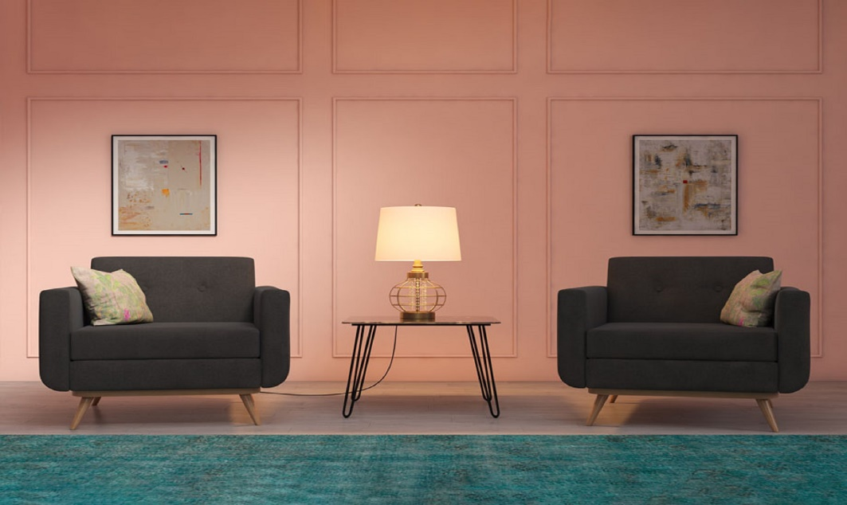**SKU:**0000000000023333324

**Availability:**140 items (In stock)

**Product Type:** Sofas/Furniture

## Rs:373000/=

### **~~Rs:425000/=~~**

Oxford Sofa is a leatherette sofa that is made with the most comfortable seat and back. It is a gorgeous shade of bright blue and is perfect for nurseries and your kids room. Dimensions: Length: 36' Width: 22' Height: 19'

**Download Description**

**BUY NOW**

**Description**

**Estimated Delivery in 15 - 20 Working Days**  
Exuding tranquillity and calmness, the Kessel sofa is a perfect pick for a cosy lounge, bedroom or even an office space. The beautiful grey shade options and angled tapered legs match any interior and instantly uplifts the environment around you. Kessel is made with supreme material for easy upkeep and plywood for additional support and is available in 1, 2, and 3 seater variants.  
  
**Sofa Kessel 3 Seater**Size:  
2139 W x 757 D x 786 H (mm)84.2 W x 29.8 D x 30.9 H (inches)Upholstered in 100% polyester fabricLegs are in beech wood with high quality polish finishSofa structure is in plywood  
Sofa Kessel 2 Seater  
**Size:**  
1538 W x 757 D x 786 H (mm)60.5 W x 29.8 D x 30.9 H (inches)Upholstered in 100% polyester fabricLegs are in beech wood with high quality polish finishSofa structure is in plywood  
  
**Sofa Kessel 1 Seater**  
**Size:**  
798 W x 757 D x 786 H (mm)31.4 W x 29.8 D x 30.9 H (inches)Upholstered in 100% polyester fabricLegs are in beech wood with high quality polish finishSofa structure is in plywood Note:The actual colours may vary from those shown depending on the device you are using to view the product or the angle of the item is photographed.



© 2023 OxfordSofa Limited. All rights reserved. Registered office: Golborne Point, Ashton Road, Golborne, WA3 3UL. Company registration number:

